# TFS Reports Read me file

## What does it do?

The application creates the full set of Quality reports in a single Excel, in one run. The structure of the Excel is as follows:

**Sheet1** contains the cumulative defects per week for extensions and core for any given project. It contains the vectors of open-fixed for core and extensions

**Sheet2** contains the cumulative "Done" Story points of all "Done" User Stories in the project filter and the associated defect density (# of Defects/Done stories). Sheet2 also contains Extensions and Core Regressions trends and a column showing the trend of Core defects as a percentage of the total.

**Sheet3** contains the bug distribution by software domains for all fixed extensions bugs.

**Sheet4** contains defect aging distribution of “open” defects – Age by week + Median age of open defects

**Sheet5** contains the “Not a bug” and “Not reproduced” percentages for Extensions and Core bugs in the project

**Note**: There is additional "hidden" data that can be exposed, such as non-cumulative data of all of the above.

Run instructions: The application operates on TFS query files ( “queryname.wiq”). These must be prepared on the TFS client and saved someplace handy. You don’t have to worry about the column options, these are taken care of by the application, only to get the right “agreed release” for the bug queries and the core dependency queries, and the “ iteration paths” (and “State = Done”) for the User Story query. **You don’t need to run the query. Just save the query file.** The installation zipfile contains all the queries I’ve been using – you can use them, but please examine them in TFS. Make sure you open them in their respective project collection otherwise the project names will be wrong.

The application is activated through a runnable jar file by double clicking it (installation instructions will follow). Note: It’s probably better to run it via batch file with the following command line: java –Xmx1024M –jar tfsreports.jar  
That way you get a console for possible errors and an extension of Heap memory  
It opens the following window:

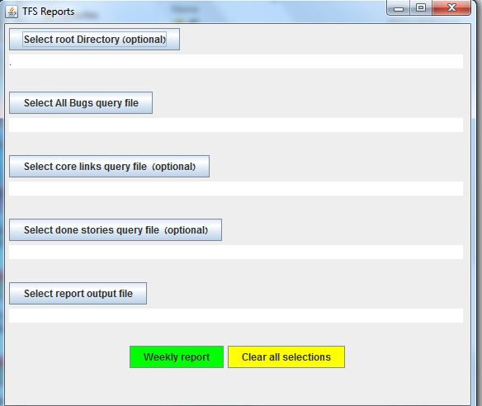

For convenience you can optionally set the root directory where the query files are located. There are two mandatory input fields – Bug Query file and output file. In order to filter out the core bugs you must also select the optional core links query file. In order to get the graph of done user stories you must select the optional user story query file. Press the “Weekly report” button and the output excel will be produced. **Note: the jxl API supports Excel 97, so it has to be .xls.** The application saves your last selections. These can be cleared using the “Clear all selections” button.

## Installation:

Due to an issue with the TFS SDK dll’s you can’t double click the jar as is. Put the jar in its own folder and using your friendly archiving utility (I used 7-zip) extract the jar contents in place.

The output will be the entire installation, including a runnable jar and all the necessary dll’s.

**Double clicking the tfsReport.jar file at this stage will run the application.**